**Assignment –6**

**Using Special Operators in Conditions.**

1. Write two different queries that would produce all orders taken on October 3rd or 4 th, 1990.

Ans. mysql> SELECT *

-> FROM orders

-> WHERE odate IN ('1990-10-03', '1990-10-04');

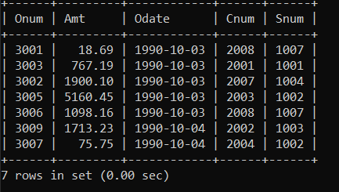

1. Write a query that selects all of the customers serviced by Peel or Motika. (Hint: the snum field relates the two tables to one another).

Ans. mysql> select * from customers

-> join salespeople on customers.snum = salespeople.snum

-> where sname in ('peel','motika');

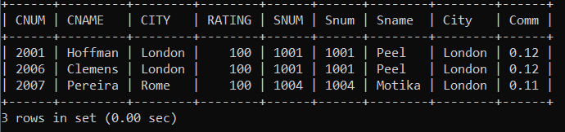

1. Write a query that will produce all the customers whose names begin with a letter from ‘A’ to ‘G’.

Ans. mysql> select * from customers

-> where cname like 'A%'

-> or cname like 'B%'

-> or cname like 'C%'

-> or cname like 'D%'

-> or cname like 'E%'

-> or cname like 'F%'

-> or cname like 'G%';

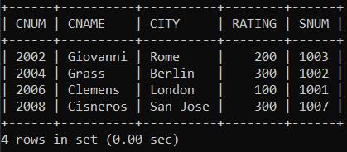

4) Write a query that selects all customers whose names begin with the letter ‘C’.

Ans. mysql> select * from customers where cname like 'C%';

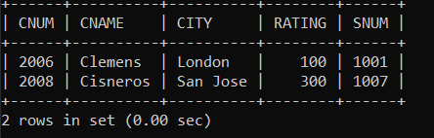

5) Write a query that selects all orders except those with zeroes or NULLs in the amt field

Ans. mysql> select * from orders where amt is not null and amt <> 0;

